EXPERIMENT I

AIM :
To understand the fundamentals of Python programming by creating and manipulating data using the Pandas library, enabling efficient organization and analysis of tabular datasets.

Algorithm:
- Import the required Python libraries, including Pandas.
- Create a dataset containing sample records.
- Convert the dataset into a Pandas DataFrame.
- Assign appropriate column names to the DataFrame.
- Display the complete DataFrame.
- Perform basic inspection of the dataset.
- Verify that the data is stored correctly in tabular format.
- Observe the output for further analysis and visualization.

Program:
print("Welcome to Data Analytics Lab")
a = 20
b = 10

print("Addition =", a + b)
print("Subtraction =", a - b)
print("Multiplication =", a * b)
print("Division =", a / b)
name = "John"
dept = "AI&DS"
cgpa = 8.9

print("Name:", name)
print("Department:", dept)
print("CGPA:", cgpa)
print("# Data Analytics Lab")
print("## Experiment 1")
print("### Jupyter Notebook")
import numpy as np

a = np.array([10, 20, 30, 40, 50])

print(a)
print("Mean =", np.mean(a))
print("Sum =", np.sum(a))
import pandas as pd

data = {
"Name": ["John", "David", "Alex"],
"Marks": [85, 90, 95]
}

df = pd.DataFrame(data)

print(df)
import matplotlib.pyplot as plt

x = [1, 2, 3, 4, 5]
y = [10, 20, 15, 25, 30]

plt.plot(x, y)
plt.title("Sample Line Graph")
plt.xlabel("X Axis")
plt.ylabel("Y Axis")
plt.show()

Output:

Welcome to Data Analytics Lab
Addition = 30
Subtraction = 10
Multiplication = 200
Division = 2.0
Name: John
Department: AI&DS
CGPA: 8.9
# Data Analytics Lab
## Experiment 1
### Jupyter Notebook

[10 20 30 40 50]
Mean = 30.0
Sum = 150
Name Marks
0 John 85
1 David 90
2 Alex 95

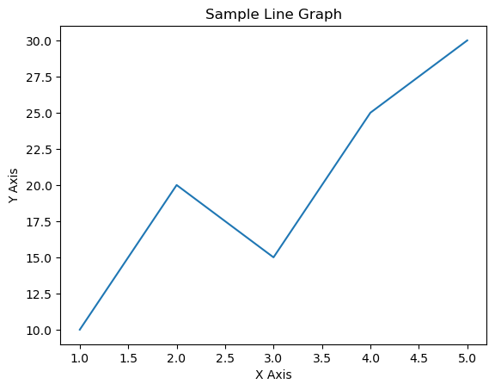

RESULT:
The Pandas DataFrame was successfully created, displayed, and verified, demonstrating the basic operations of data organization and manipulation using Python.

